Date: 29.04.2022
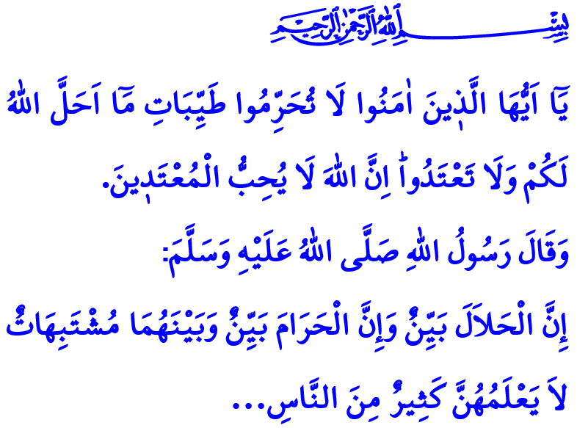
LIVING A HALAL LIFE
Honorable Muslims!
In the verse I have recited, our Lord Almighty (swt) states, “O you who have believed! Do not prohibit the good things which Allah has made lawful to you and do not transgress. Indeed, Allah does not like transgressors.”
In the hadith I have read, our Prophet (saw) says, “What is lawful is clear, and what is unlawful is also clear. And between them are matters that are not clear, about which not many people know. Thus he who guards against the unclear matters clears himself with regard to his religion and his honor. But he who falls into the unclear matters falls into that which is unlawful...”
Dear Believers!
Halal and haram are the boundaries established by our Lord (swt) for us in this life. Halal and haram are far-reaching notions that cannot be reduced to food and drink. Halal and haram are the name of the awareness on which life is built. This awareness extends to all moments and facets of life, from intentions to words, thoughts to actions, dressing, food and drink, shopping to consumption, and family relationships to relationships with neighbors.
Dear Muslims!
Any word or action that protects the pure disposition our Lord (swt) has bestowed upon us is halal. Everything that upsets such disposition and harms our chastity, dignity, and grace is forbidden. All the niceties that are in accordance with Allah’s (swt) approval are halal. Haram, on the other hand, refers to all the unsavory things that invoke His (swt) wrath. Both halal and haram are part of the trial. Being satisfied with halal is a kind of worship, as is refraining from haram. To regard what is halal as haram and what is haram as halal is a grave sin that harms one’s faith.

Dear Believers!
According to our religion, the authority to determine what is halal and what is haram is vested in Allah (swt) and, with His permission, in our Prophet (saw). In the Holy Qur’an, our Lord (swt) has taught us what is halal and what is haram. Our Prophet (saw), on the other hand, showed us how to live as a believer. In his (saw) words, the believer is like a bee. It eats pure and wholesome halal things, and produces that which is pure and wholesome. When it lands on something it does not break or waste it. It always pursues what is good and pleasant as well as good deeds.
Dear Muslims!
We can live a peaceful life as long as we avoid evil and surround ourselves with good. The further we move away from haram, the closer we get to our Lord’s (swt) mercy. We are elevated in the sight of Allah (swt) as long as we keep our distance from sin. When we fill our hearts with love, compassion, mercy, loyalty and sincerity, we discover our true path. We get lost in the dark when we are guided by hate, hatred, vengeance, lies, and deception. When we behave in line with halal and haram awareness, we gradually make our way to paradise. We eventually regret and become frustrated if we are involved in haram.
Dear Brothers and Sisters!
On the occasion of this last Friday of Ramadan, the month of mercy and forgiveness, as well as of the eve of the Eid, let us pay attention to the line between halal and haram so as to turn our eternal life into a festival. Let us not transgress the boundaries Allah (swt) has set out. Let us all say “ameen” wholeheartedly to our Prophet’s (saw) following supplication: “My Lord! Make me grateful to You, remember You, fearful of You, obedient to You and humble to You, who always supplicates You!”
Dear Believers!
As I conclude this Friday’s khutbah, I would like to make an important point. Numbered days are left until we welcome the Eid. Starting from today, many of us will hit the roads to spend the holiday with our loved ones. We should exercise extra caution on the road in anticipation of greater traffic at the start and finish of the holiday. I would like to take this opportunity to ask all of you, my brothers and sisters, to obey traffic rules and to be patient, understanding, and cautious, and to respect each other’s rights.

Ma‘idah, 5/87.
Bukhari, Iman, 39; Muslim, Musaqat, 107.
Ahmad ibn Hanbal, II. 199.
Ibn Majah, Du’a, 2. General Directorate of Religious Services

